Machine Learning Predicts Supreme Court Decisions

Arpit Jasapara, University of California, Los Angeles

Abstract
Daniel Martin Katz, Michael J. Bommarito II, and Josh Blackman use machine learning as a technique to predict Supreme Court decisions. They obtain their data from the Supreme Court Database, and break it up into key features about each justice and case. Using these features, they create a random-forest model that evolves over time. This model uses data prior to the case to form predictions. Katz and his team obtained accuracy rates of 71.9% and 70.2% for justice and case prediction respectively [1], and compared the results to three baseline models. Their model outperformed each of the three baseline models by significant margins. Their model is also considered a success because it is consistent and general, in that it applies to any set of justices. These results represent the importance of machine learning as a tool for prediction, and explore the numerous possibilities to export this model to other applications.
1. Introduction
The Supreme Court stands as the most powerful institution in the United States of America. It is in charge of ensuring that the government adheres to the Constitution, and as such, makes many landmark decisions. There are nine justices at any given time, and they each have a tenure of roughly 20 years [1]. Their positions of power also come with several responsibilities. One of their major responsibilities is that they have to write in-depth explanations for their decisions. A simple majority vote is followed by three opinions written for each case: a majority, a concurring, and a dissenting opinion. A majority opinion is written by the majority of justices in favor of a decision, making this the primary opinion. A concurring opinion is written when a justice agrees with the majority decision, but for different reasons. Lastly, a dissenting opinion is written by the justices who do not agree with the majority decision.
For example, if the case is on legalizing open immigration, and the majority of the justices are not in favor, then the majority opinion may cite safety concerns as the reasoning, the concurring opinion may cite an influx of cheap labor as the reasoning, and the dissenting opinion may cite a larger, more productive labor force as the reasoning.
Thus, there is plenty of data on the thinking behind each justice’s decision available to the open public. Daniel Martin Katz, Michael J. Bommarito II, and Josh Blackman use this data to create a machine learning model that can predict the Supreme Court’s decisions [4].
2. Methods
Data collection was the first important method. The team primarily used the Supreme Court Database (SCDB) to obtain all the data for each justice and the overall outcome of the case. First they collected the raw numbers on the three ways a justice can vote: affirm, reverse, or other (abstain, absent, etc.) and the two outcomes of a case: affirm or reverse. Then, they associated each justice with their vote, and scanned their opinions for key words, that they labeled as features [2]. These features then allowed the team to build profiles for each justice to categorize their behavior, especially on controversial issues such as immigration and abortion. Similarly, they associated each case with its outcome, and then scanned the opinions of the case to see how each justice influenced the case and what features are important. They came up with 16 primary features that are the most relevant in predicting justice and case outcomes [4]. Katz and his team then combined all this data into the backbone of their prediction application: the random forest machine learning model.
2.1. Machine Learning Model: Random Forest
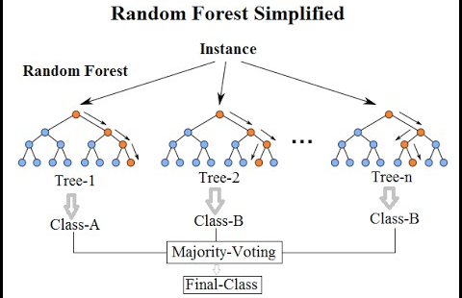
The random forest machine learning model is a popular tool used by many data scientists to combine vast amounts of data in a meaningful manner to see patterns. It works by creating several trees representing the general characteristics of each data point. Then it creates a regression of these trees to predict what the average tree would look like, and identify subsequent patterns.

Figure 1 [3]. Visual representation of the Random Forest model that shows the averaging of trees into a final class.
3. Results
The results of the first run were very accurate. The precision for the prediction of each individual justice’s vote came out to 65%, and the recall was 66%, so the F-1 score which averages the two in a sense, comes out to 65% [2]. Similarly, the results for the accuracy for the prediction of overall case outcome are shown below.
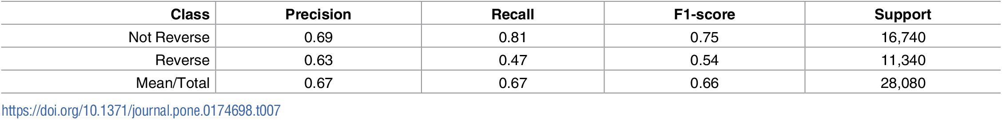

Figure 2 [2]. The accuracy of the model’s predictions for case outcomes.
3.1. Comparison to Baseline Models
The researchers came up with three baseline models, to compare the results with their model, and get a better understanding of how accurate their model is. These comparisons allow Katz and his team to concretely assert that their model is better and more accurate.
The first model is the “always guess reverse” model. This model is based off the idea that historically, the Supreme Court reverses decisions. When compared to the team’s machine learning model, however the “always guess reverse” model was not even close. The team’s random forest model beat this model in all the justice predictions, and the vast majority of the case outcomes.
The second model is the infinite memory model, which averages out the court’s decisions from 1816 to now to make relevant predictions. However, similarly to the “always guess reverse” model, this model performed poorly in comparison to the random forest model.
The third and most accurate of the three models is the optimized finite memory model, which only averages out the decisions from a certain window around the case in question. The most accurate window was found to be 10 years, but when compared to the team’s random forest model, it was also not as accurate.
In terms of statistical values using the paired t-test, Wilcoxon rank-sum, and the binomial test, each of the p-values were very close to 0 for each baseline model [2], indicating that the results of the comparisons were not random. Thus, the team proved beyond a doubt that their random forest model outperforms all of these baseline models, and obtains the high accuracy rate of over 70%.

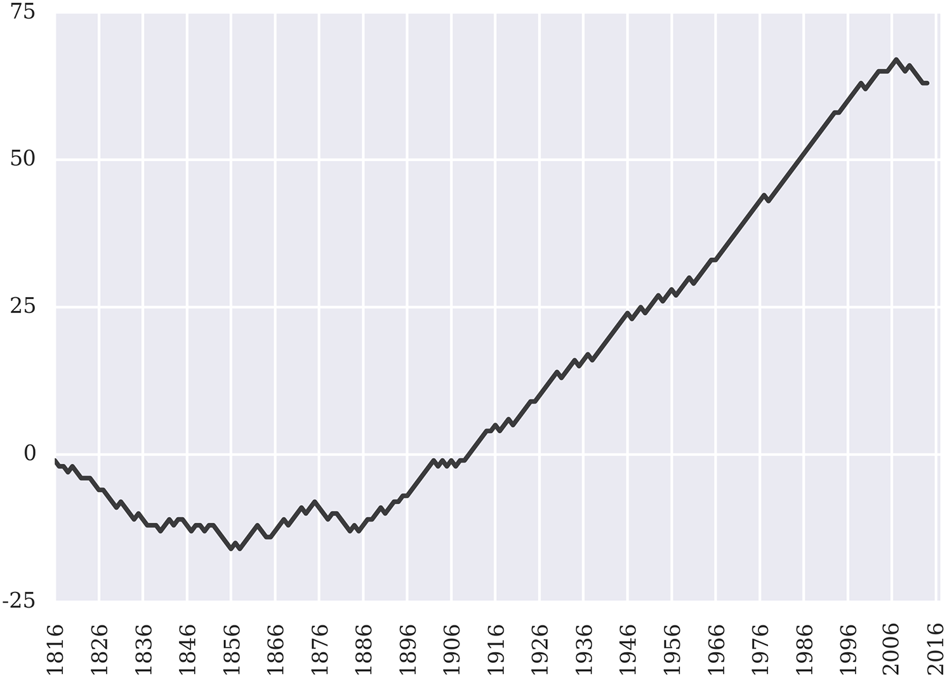

Figure 3 [2]. This graph represents the percent of correct predictions of the random forest model when compared to the optimized finite memory model. It starts initially low for the 1800’s, but quickly rises to above 70% for the modern era.
4. Discussion
Currently, the most popular prediction models for the Supreme Court average around 50% accuracy, which makes them about as useful as flipping a coin. On the other hand, this random forest model boasts an accuracy rate of over 70% [1]. The researchers realized that there is a need for more-accurate prediction models, especially in the law industry. They hope to market this model to lawyers who can better understand how the Supreme Court works, and use specific key words to improve their chances of winning. Thus, if both sides use this model, then both sides will present their best arguments, and the ultimate decision will come down to facts, and not what certain key words influenced the judge’s decision.
This model also has the potential to be exported to other applications such as jury selection. It can even be exported outside of the law industry, such as to predict judges’ decisions on American Idol. Katz and his team also hope that this model will increase the research around machine learning models, and demonstrate their importance in prediction algorithms. Hopefully, future advancements can improve upon common machine learning models such as random forest, to yield even higher prediction rates such as 90%. Machine learning evidently has several practical applications in all sectors of the world, and will shape the future for generations to come.
References
[1] Hutson, Matthew. "Artificial intelligence prevails at predicting Supreme Court decisions." Science Magazine. N.p., 2 May 2017. Web. 29 May 2017. <http://www.sciencemag.org/news/2017/05/artificial-intelligence-prevails-predicting-supreme-court-decisions>.
[2] Katz DM, Bommarito MJ II, Blackman J (2017) A general approach for predicting the behavior of the Supreme Court of the United States. PLoS ONE 12(4): e0174698. <https://doi.org/10.1371/journal.pone.0174698>.
[3] Kumar, Niraj. Random Forest Algorithm. Digital image. LinkedIn. N.p., 17 June 2016. Web. 29 May 2017. <https://www.linkedin.com/pulse/random-forest-algorithm-interactive-discussion-niraj-kumar>.
[4] "AI Prevails at Predicting Supreme Court Decisions." ACM TechNews. 5 May 2017. Web. 29 May 2017. <http://technews.acm.org/archives.cfm?fo=2017-05-may/may-05-2017.html>.

